TASK 12:

Create 3 subnets

o Web tier

o App tier

o DB tier

•Configure Network security Group

o DB tier should not access any tier (Web &amp; App)

o App tier should access the DB tier and Web tier.

o Web tier should only access App tier.

• Only web tier should have access to internet.

Steps:

Step 1: Create virtual network with name ‘vnet’.

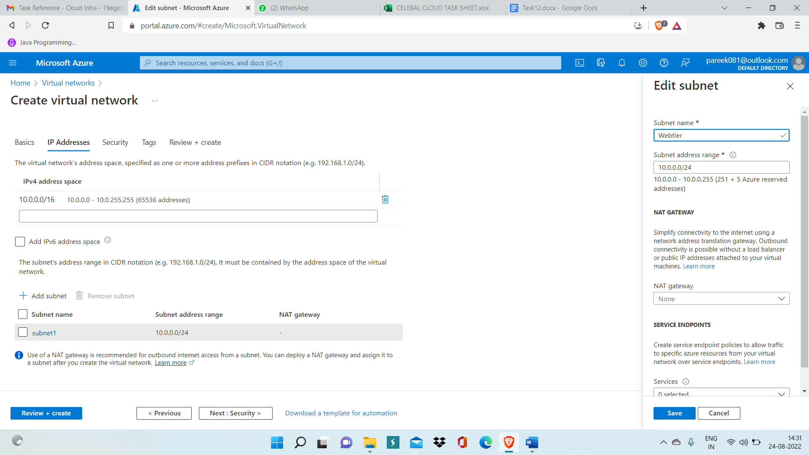

Step 2: Now inside ‘vnet’ create three subnet with name Apptier, Webtier, DBtier with different CIDR ranger.

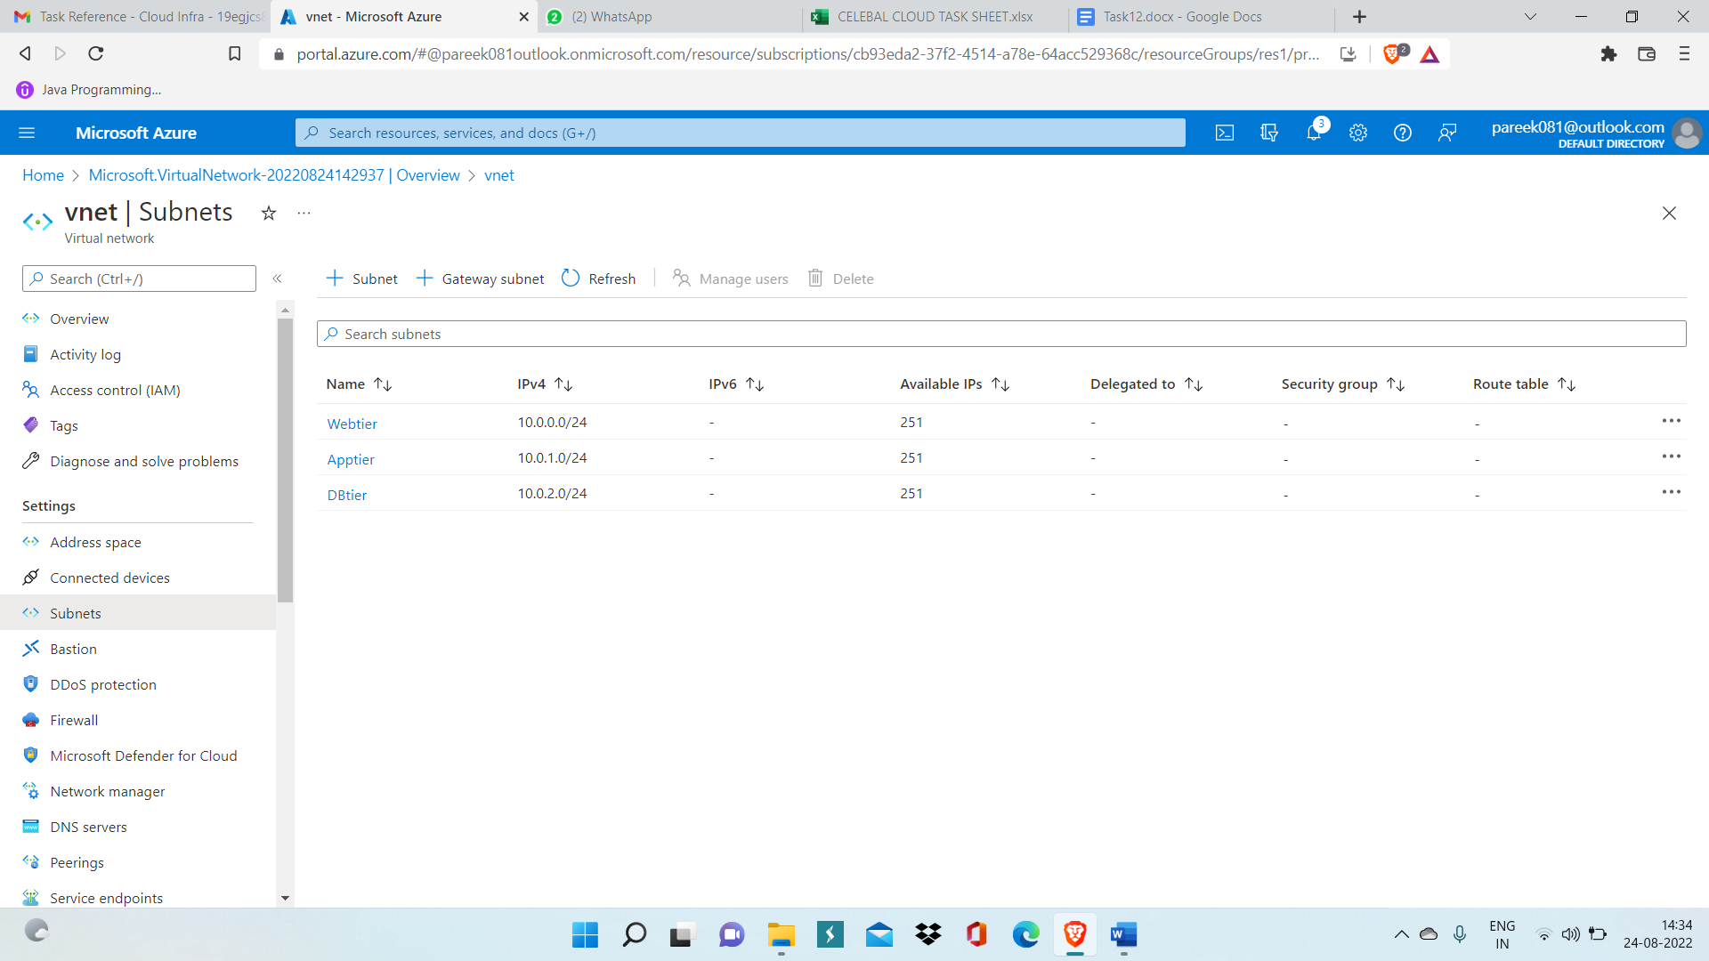

Step 3: Now create virtual machine for each subnet

For Webtier create VM with name ‘vm-Webtier’

For Apptier create VM with name ‘vm-apptier’

For DBtier create VM with name ‘vm-DBtier’

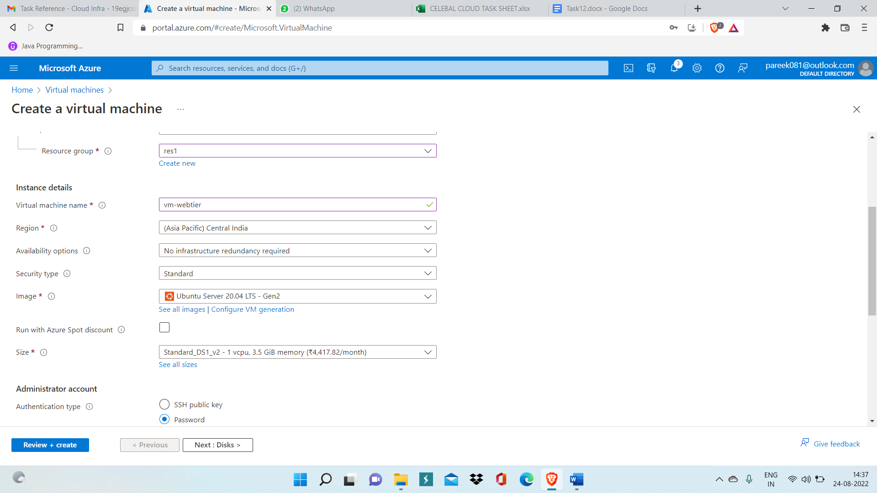

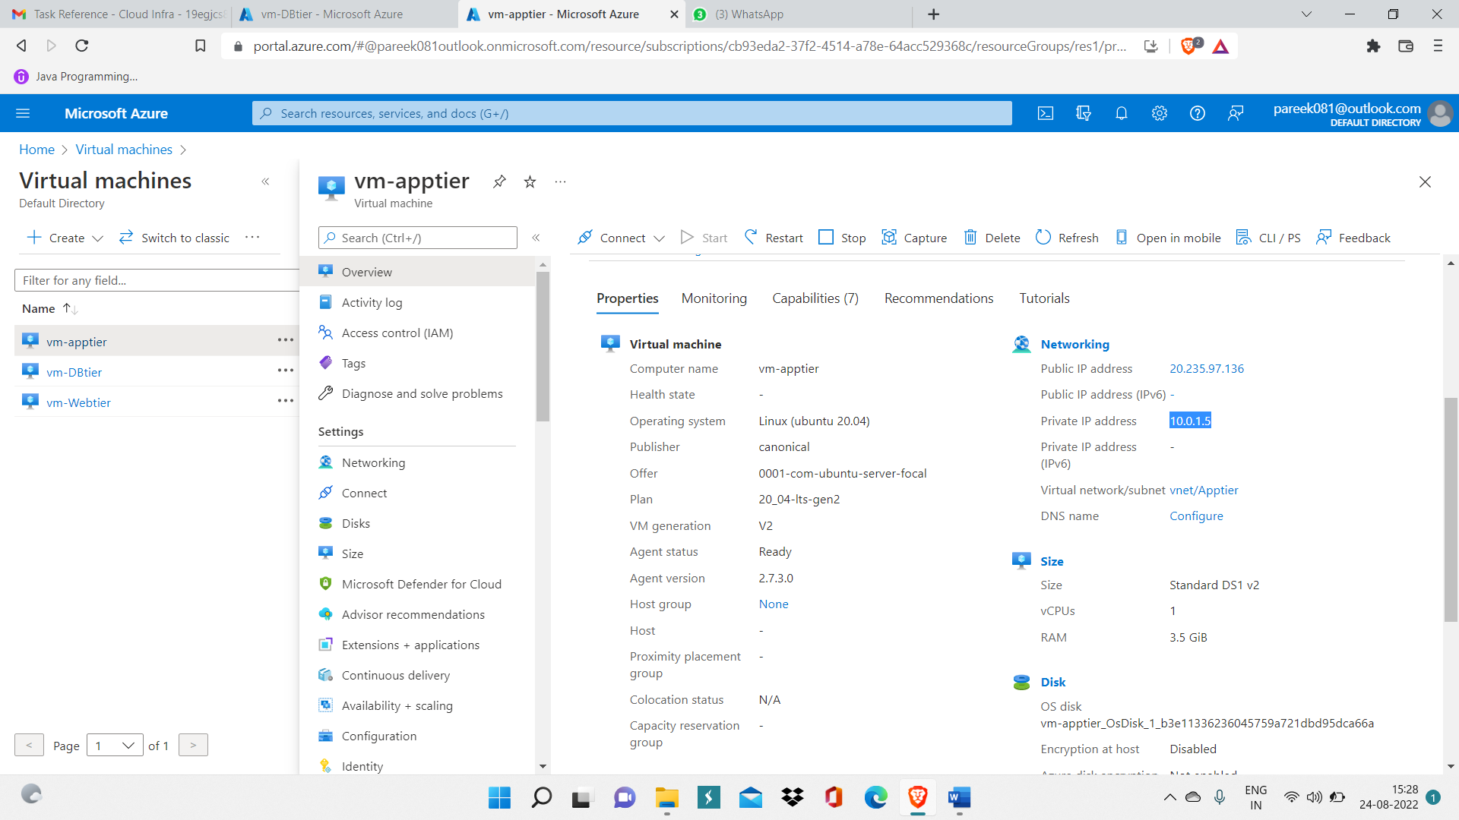

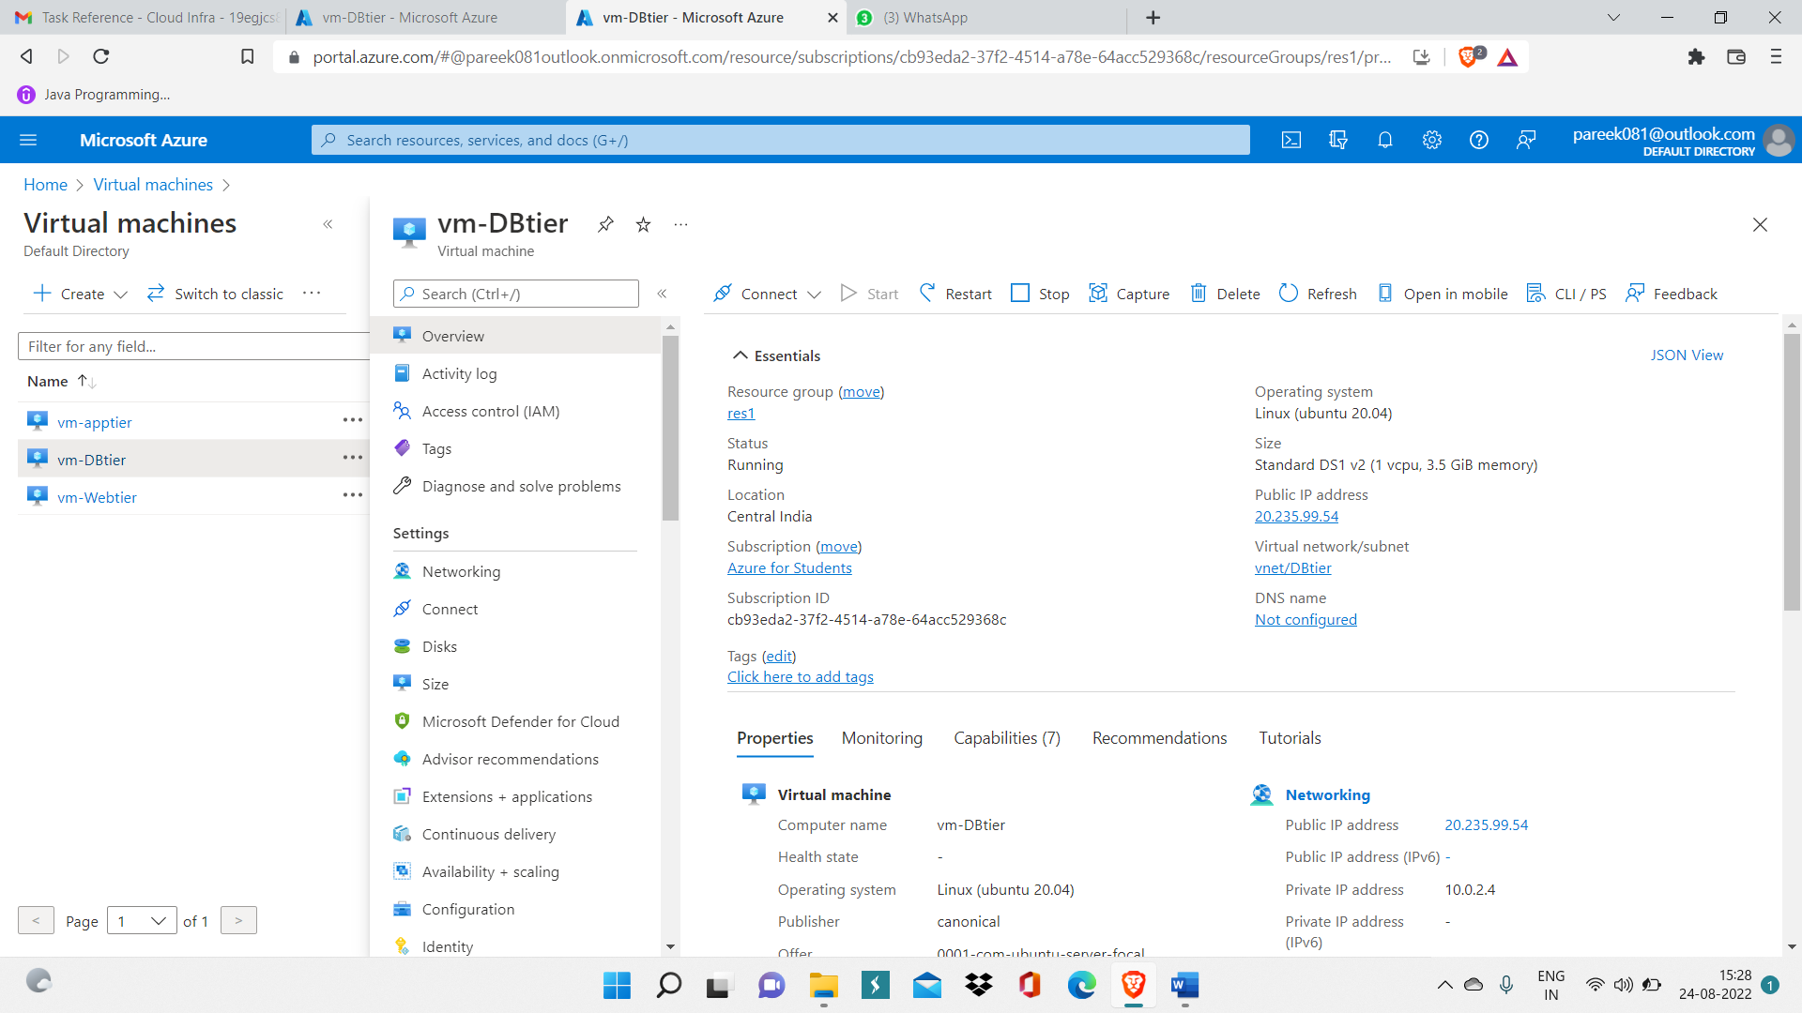

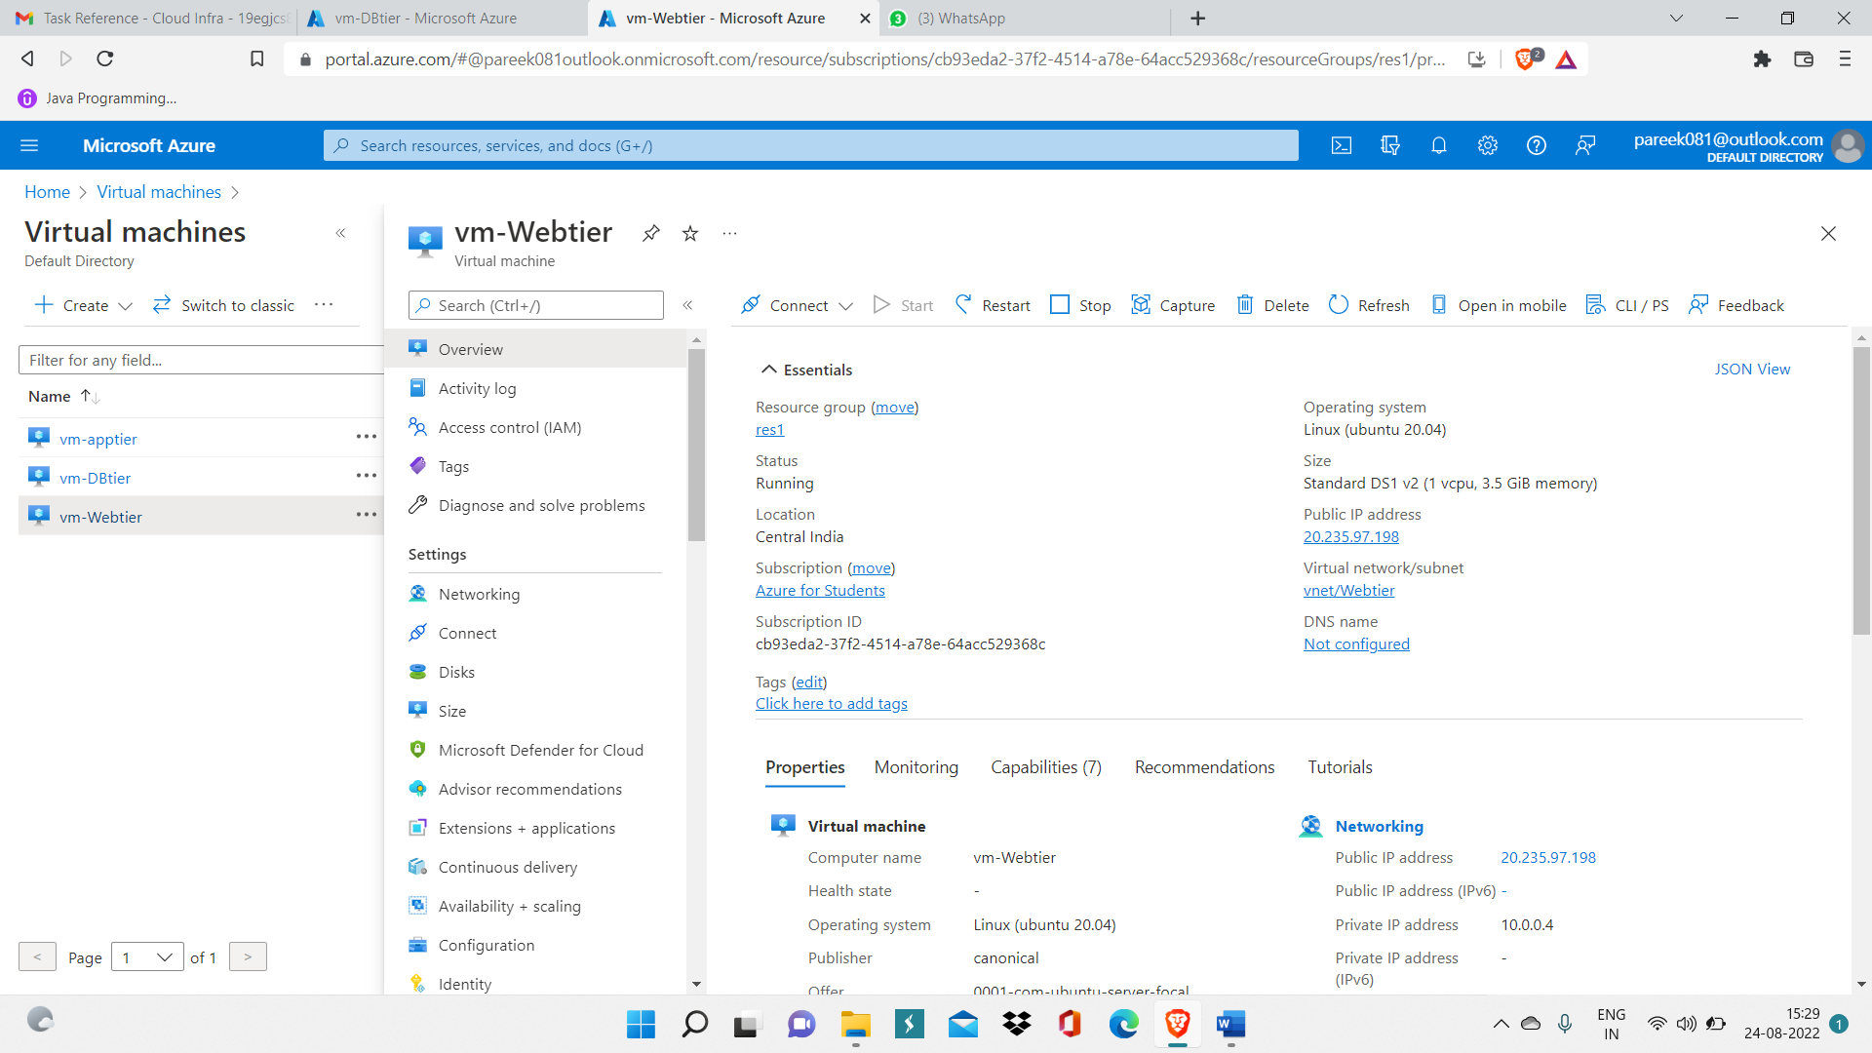

Step 4: Now run command: ssh <username>@<public IP of VM> to connect to VM.

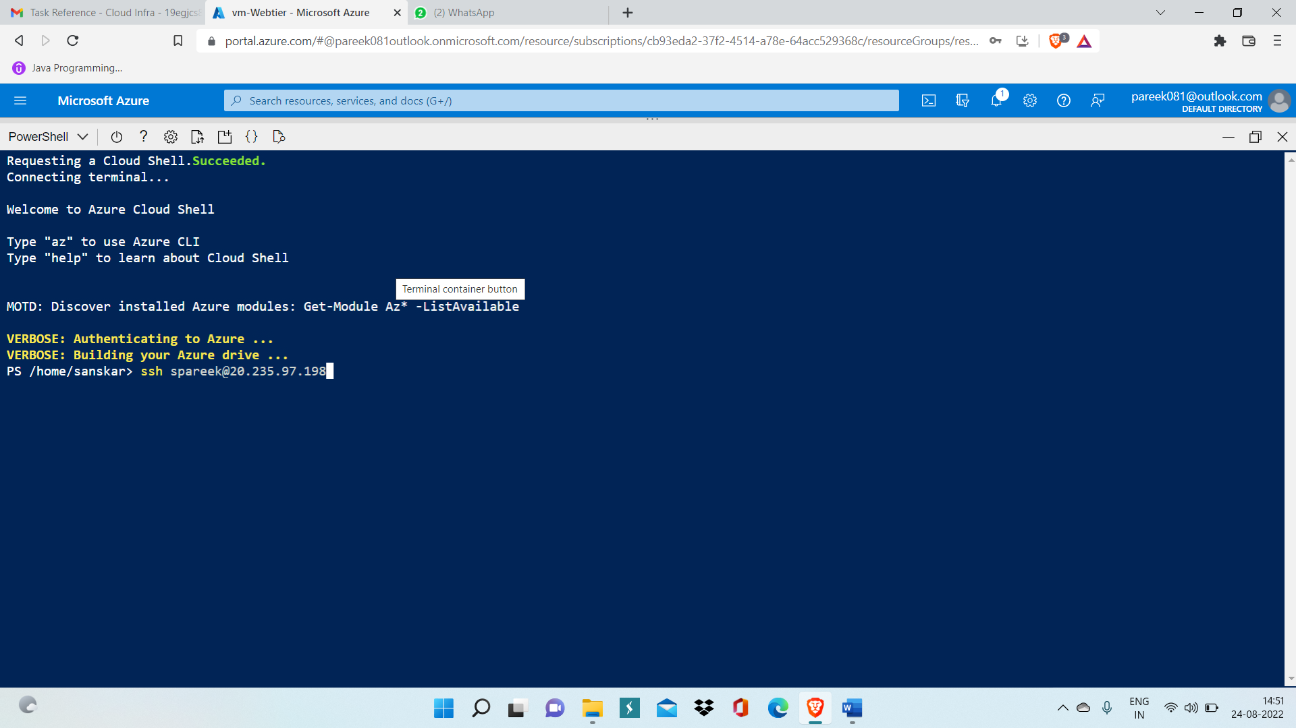

Step 5: Run command: ping <private IP of another VM> you created in other subnet(Webtier and DBtier)

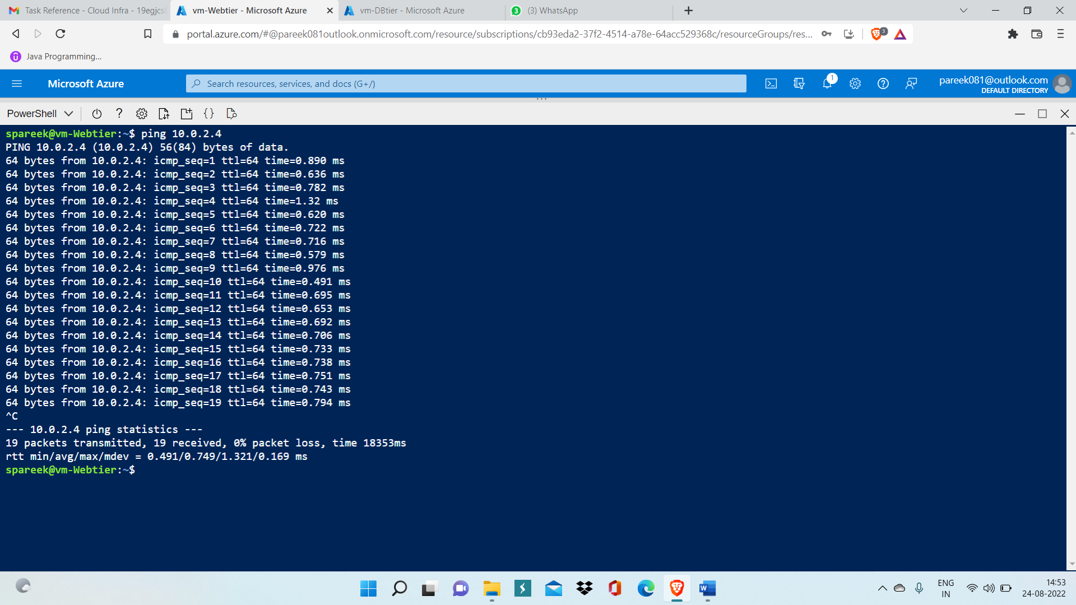

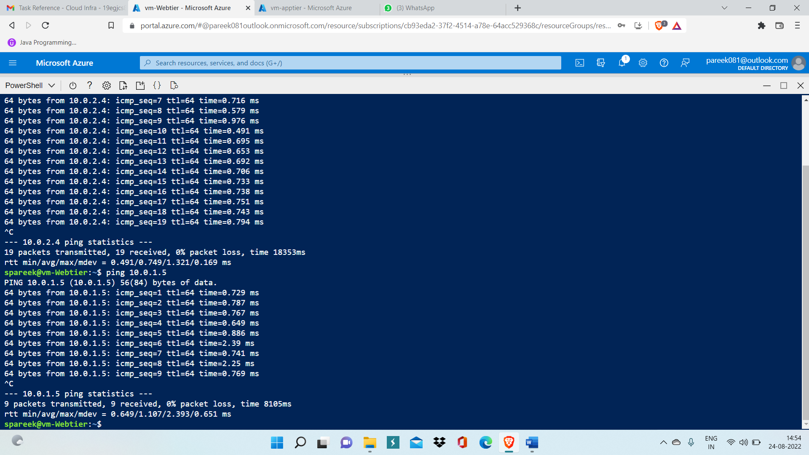

Step 6: Configure network group to stop internet connectivity of Apptier and DBtier

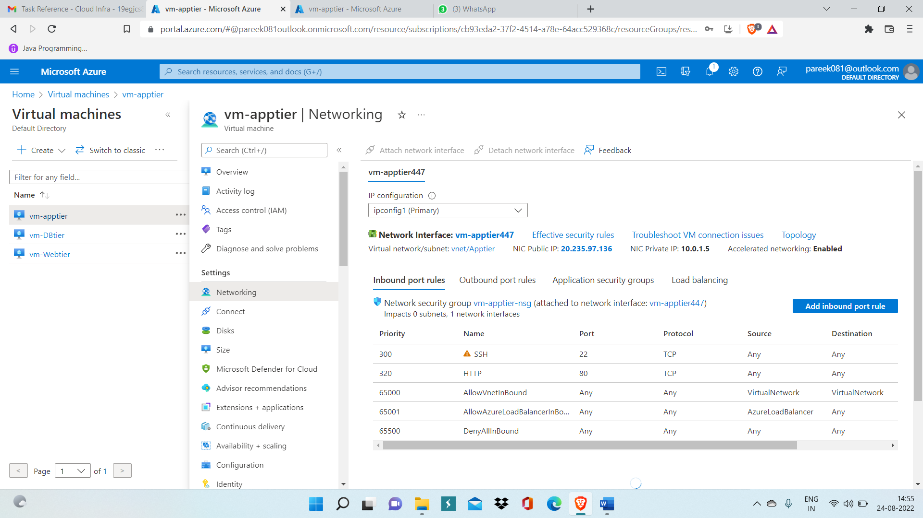

Step 7: Now inside DBtier add outbound security rule with Deny action and click on Add.

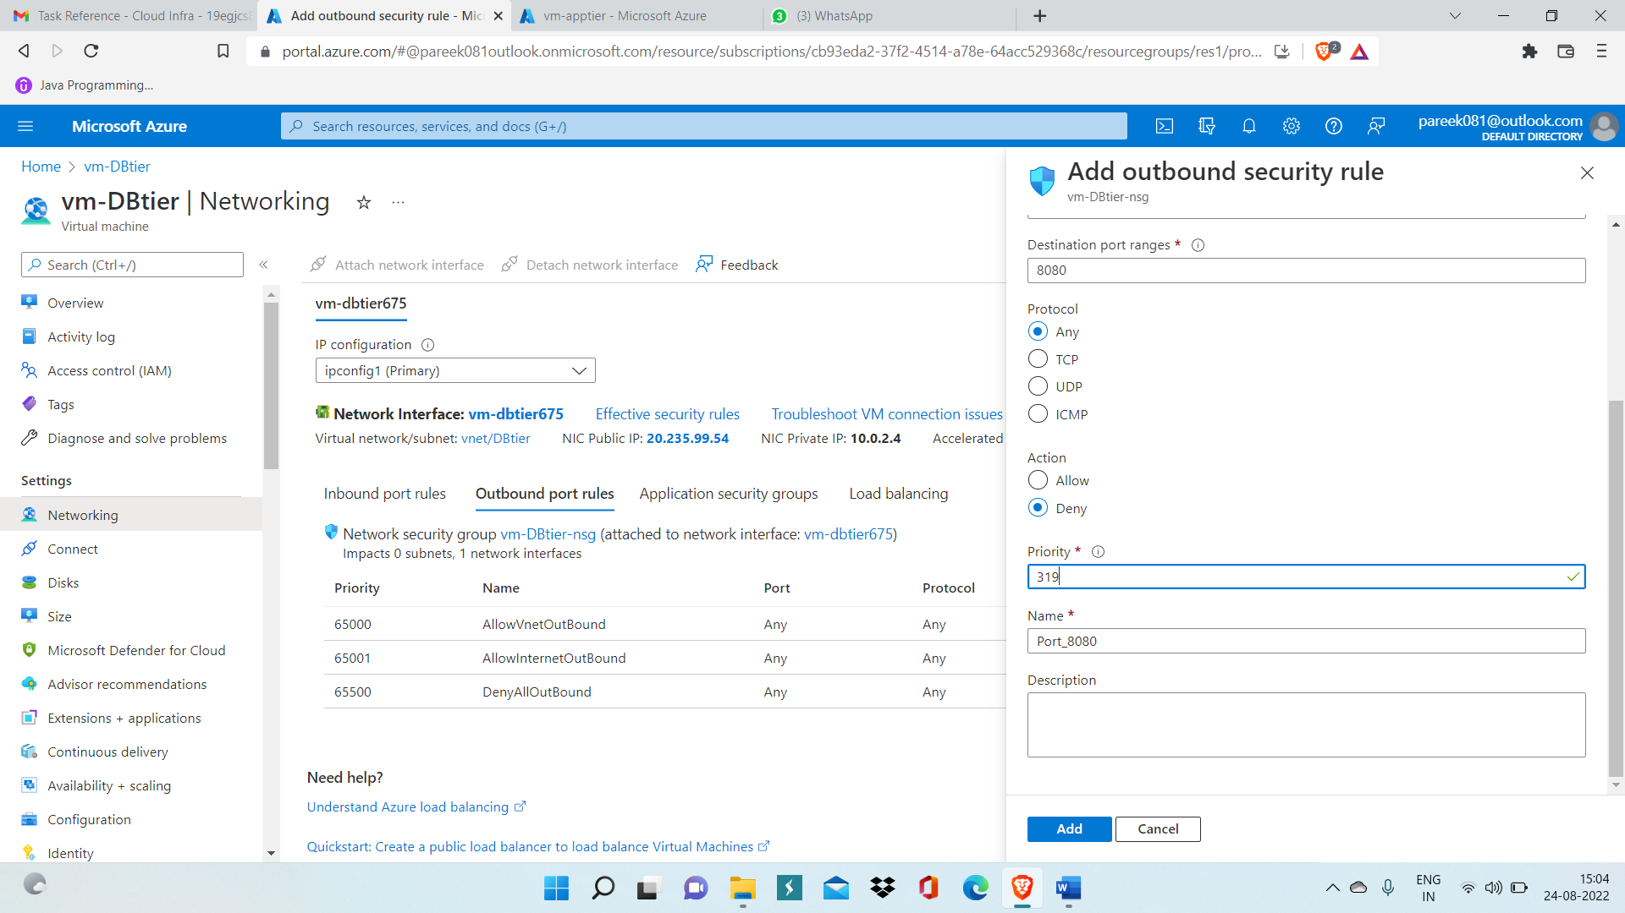

Step 8: Add outbound security rule with priority 445.

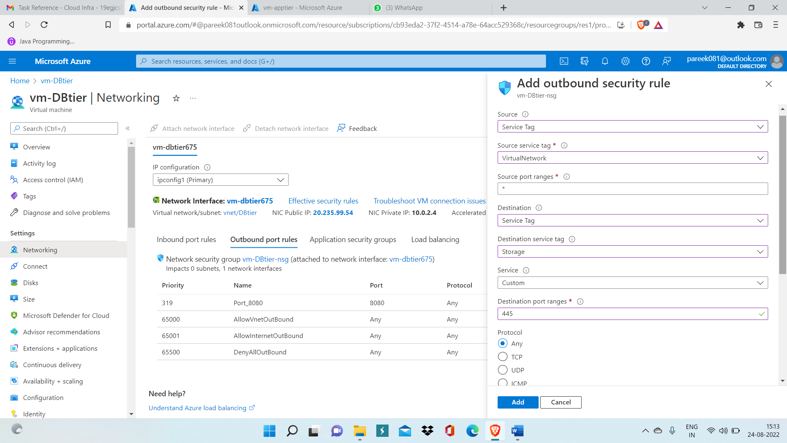

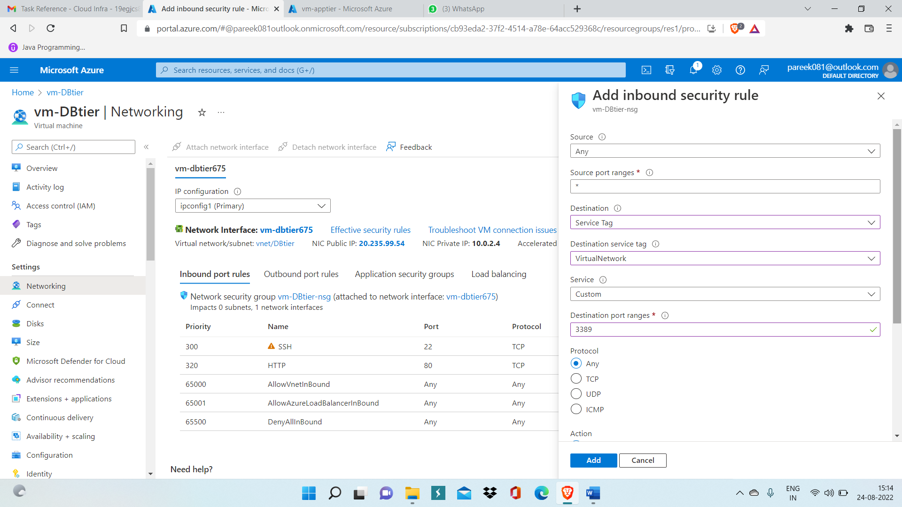

Step 9: Now inside DBtier, create Associate subnet.

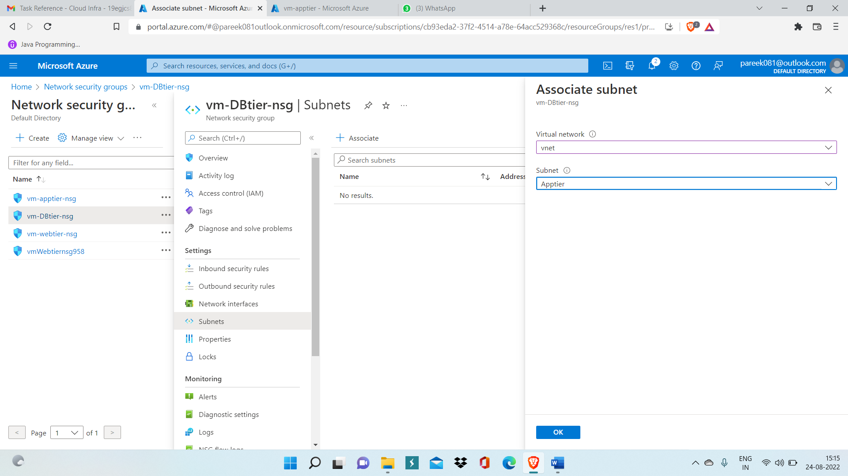

Now DBtier can’t access any tier and only WebTier only has access to Internet as in other two tier we have created deny action outbound security rule.